17.62: Equating the heat lost by the lead to the heat gained by the calorimeter (including the water-ice mixtue),

Solving for the final temperature T and using numerical values,

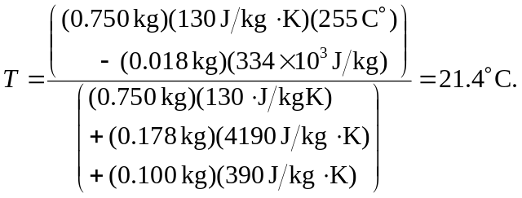

(The fact that a positive Celsius temperature was obtained indicates that all of the ice does indeed melt.)

